Two sentence stories
https://onthesamepageelt.wordpress.com/2017/05/16/two-sentence-stories/

Ten popular two-sentence horror stories have been divided into three columns for students to match the beginning, middle and end. The goal here is for students to use contextual and cohesive clues that will allow them to rewrite these stories, starting with the beginning of each story under column A, then choosing the next part under column B, and finally thinking of a suitable ending under C. In addition, the students are asked to decide where the missing full stop between the first and the second sentence in each story should be.
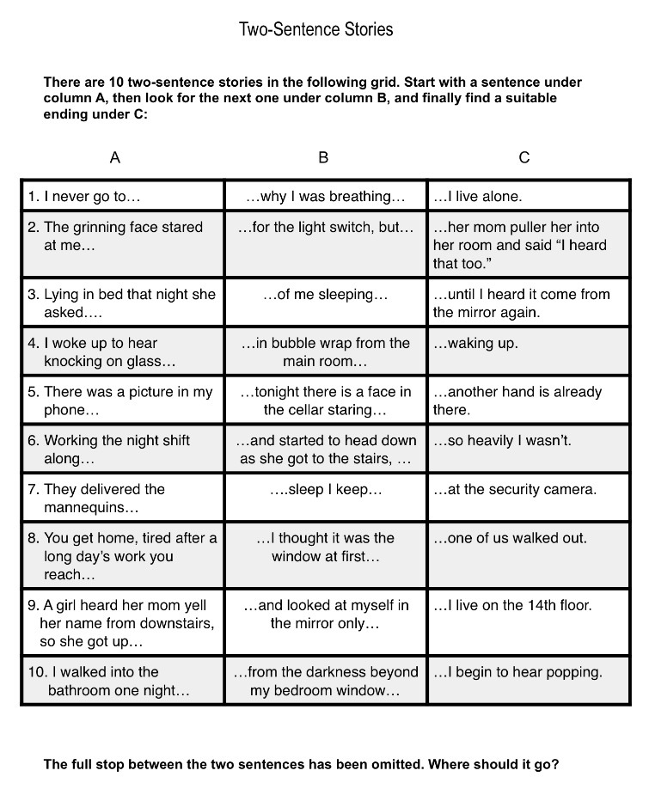
Two-Sentence Stories.pdf

ANSWERS:
1. I never go to sleep. I keep waking up.
2. The grinning face stared at me from the darkness beyond my bedroom window. I live on the 14th floor.
3. Lying in bed that night she asked why I was breathing so heavily. I wasn’t.
4. I woke up to hear knocking on glass. At first, I thought it was the window until I heard it come from the mirror again.
5. There was a picture in my phone of me sleeping. I live alone.
6. Working the night shift alone tonight. There is a face in the cellar staring at the security camera.
7. They delivered the mannequins in bubble wrap. From the main room I begin to hear popping.
8. You get home, tired after a long day’s work and ready for a relaxing night alone. You reach for the light switch, but another hand is already there.
9. A girl heard her mom yell her name from downstairs, and started to head down. As she got to the stairs, her mom pulled her into her room and said “I heard that too.”
10. I walked into the bathroom one night and looked at myself in the mirror. Only one of us walked out.

The students choose the three stories they find the creepiest, write a brief explanation for each of them, and share their thoughts with the rest of the class.
Now display the following:
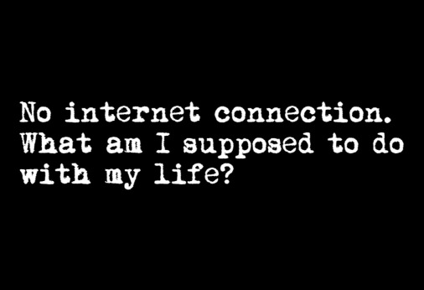
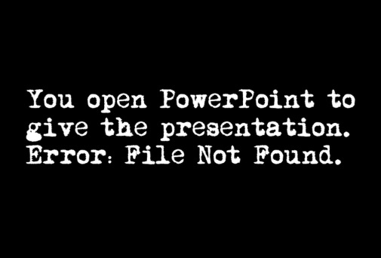
What is scary about this? Why? Think about the tiny little things and everyday struggles of life in the 21st century. What “scares” you the most?
After brainstorming a few ideas as a whole group, ask the students to come up with a two-sentence story featuring one of those everyday life “struggles”, edit it, publish it, and then share it. My students are teenagers in Spain, so most stories were about technological issues, social media, school (especially exams and deadlines) or getting around the city.
Your alarm goes off and you hit the snooze button for 5 more minutes. When you wake up, you realise your final exam was an hour ago.
You have been stalking a friend on Instagram. Suddenly, you accidentally like an old picture.
That was a long queue to get on the bus. My travel card had expired and I had no money on me.
9:00 a.m.. 7% battery life and no charger.
The final discussion based on these stories allowed the students to share experiences and make personal connections with each other in an active, student-centred learning environment that also encouraged critical thinking as the students analysed and assessed these attitudes and behaviours.

