Storytelling
https://www.cambridge.org/elt/blog/2018/11/01/creative-storytelling-classroom-activity/

Is it true?
This is a simple storytelling game with plenty of room for adaptation. It gives students an opportunity to be creative in thinking of, and developing, a story, while also ensuring that students are encouraged to listen to each other. It could be used as free practice for the narrative tenses for intermediate and upper-intermediate students, or as an ice breaker for higher levels.

Preparation
Students will have to think of a story and can either make one up completely or tell the truth. I have prepared a handout to help students generate ideas, but you could easily choose your own ideas or restrictions for your class to use to generate stories.
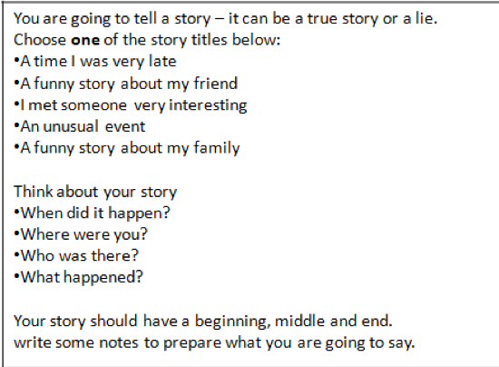
Before the lesson you also need to prepare a story about yourself. You can either tell a true story that seems unbelievable, or make one up that seems believable. Either way, have the details clear in your mind so you don’t hesitate when you’re speaking and you’re able to answer questions about it from the class.
In class, ask your students to listen carefully to a story you’re about to tell them. They need a listening task, so if you’re explicitly looking at narrative tenses, ask your students to write down the verb forms they hear. Tell the story twice and make sure that you say it exactly the same way both times by reading out a prepared written version. After feedback with the answers, you reveal that the story might not be true. Students then discuss the story in pairs and decide if they think your story was true or not. Take some guesses and ask for reasons before giving them the answer.
Alternatively, ask students to listen to your story and tell them ahead of time that it may, or may not, be true. The first time they listen, they should try to think of questions they could ask to help them decide if it’s true or not. After telling the story once, students discuss their questions in pairs before selecting one question each to ask you. After you answer the questions, give them a summary of the story again and ask them to decide if it’s true or not.

How to play
Students are now going to play the same game with each other. First, they need to generate a story, whether it’s true or made up. Using the cards and discussing their ideas in pairs, students should take notes and write down the key details of their story. Some students will try to skip this part, having quickly generated a quick anecdote in their head and deciding it’s enough. Be clear that this should be an interesting story that isn’t too short.
Ask early finishers to write down key events, characters and details that other students might ask them about. They can also practice telling their story with their partner. How much support and time you give to this stage depends on your class, but it’s important that every student is ready to tell their story before you move on. When everyone is ready, students mingle and speak in pairs. They take it in turns: the first student tells their story to completion without any interruptions, then their partner can ask questions and ask them to repeat any details that weren’t clear. They then have to guess if it was a true story or not before swapping roles. For a bigger or more chaotic class I would use a ‘speed dating’ seating arrangement rather than a mingle.
To make it more of a ‘game’ write the students’ names on the board and keep a tally. When they guess correctly, or fool another student, they get a point. Some students are really motivated by this kind of competitive element, but it depends on your class. With teenagers, and some adults, it can be essential to encourage them to listen to each other properly. Once you’ve had four or five rounds, students sit back down in their pairs and discuss the stories they heard. You can write some prompts on the board, like:
- Whose story was the best/most interesting?
- Who did you fool/who fooled you?
- Who’s a good/bad liar?
- What story would you tell if we played the game again?

Finally
With attentive monitoring you should have plenty of language for delayed error correction. You can also pause the game after a round or two for some language input if you keep hearing the same errors or some particularly good language that’s worth highlighting.
I’ve played a slight variant of this game where the focus was on follow up questions. In this version students have to tell a true story but lie about three specific details. Students have to ask probing questions to get to the truth and get a point for each lie they identify.

