Pile of Words: Drive Deeper Engagement with Vocabulary at the Beginning of a Unit, Text, or Project

https://catlintucker.com/2021/04/pile-of-words
Each new unit, text, or project presents learners with vocabulary words that may be new and unfamiliar. So, how do we get students to think more deeply about vocabulary? How can we make learning new vocabulary more engaging and meaningful? Matthew Perini, Harvey Silver, and Jay McTighe propose a simple yet powerful strategy called “pile of words.”
I love the pile of words strategy because it positions the students at the center of learning. Instead of the teacher simply pre-teaching vocabulary or presenting a word bank or word wall of key terms, the pile of words strategy challenges students to engage in conversation, work collaboratively, and think critically about vocabulary.
Here is how it works!
Step 1: Think about the unit, text, or project you are about to start and create a list of vocabulary words and key terms.
Select a list of vocabulary words and terms central to the unit, text, or project you are about to begin with your students. 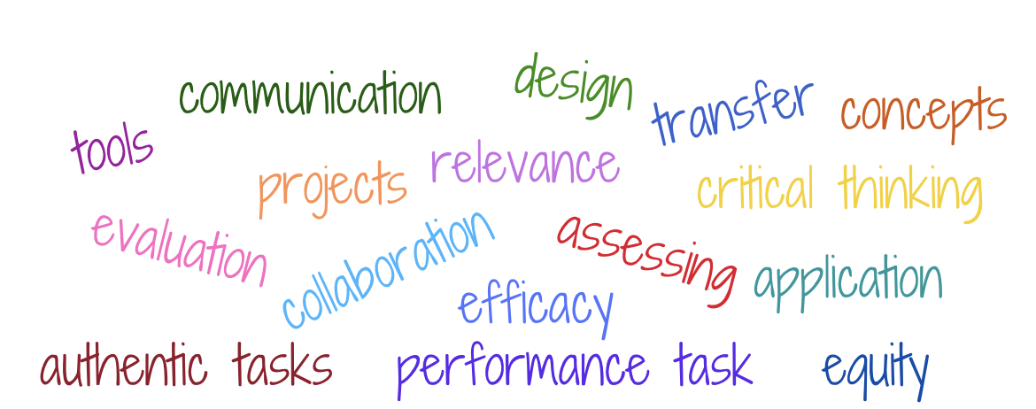This is the following pile of words from a text we were about to begin.

The size of your pile of words should be large enough to allow for sorting and grouping without overwhelming learners. If you are working with younger learners, you may want to keep your pile of words smaller. A third-grade teacher might present students with six words, whereas a tenth-grade teacher might present 15-20 words. You are the best judge of how many words you think your students can handle for an exercise like this.
Step 2: Group students and give them time to discuss and define.
Give students time to discuss and define the words. Which words do they know? Which do they need to define using online resources? Encourage them to capture their definitions in their notes so they are easy to reference throughout the unit, text, or project.
If you are working with younger learners, you may want to provide resources they can use to look up unfamiliar words or even provide them with definitions after they have had the opportunity to discuss and define the words they do know.
Step 3: Group the words into categories by shared characteristics and label each category.
Once students have defined the words, they should work collaboratively with their group to create categories. Which words share common characteristics? What would you label this category of words to reflect their commonality? Put the words with shared characteristics together in a category and give that category a name or label.
The students worked in breakout rooms using a Jamboard to organize and label their words. I invited them to make as many categories as they needed to sort and group the words.
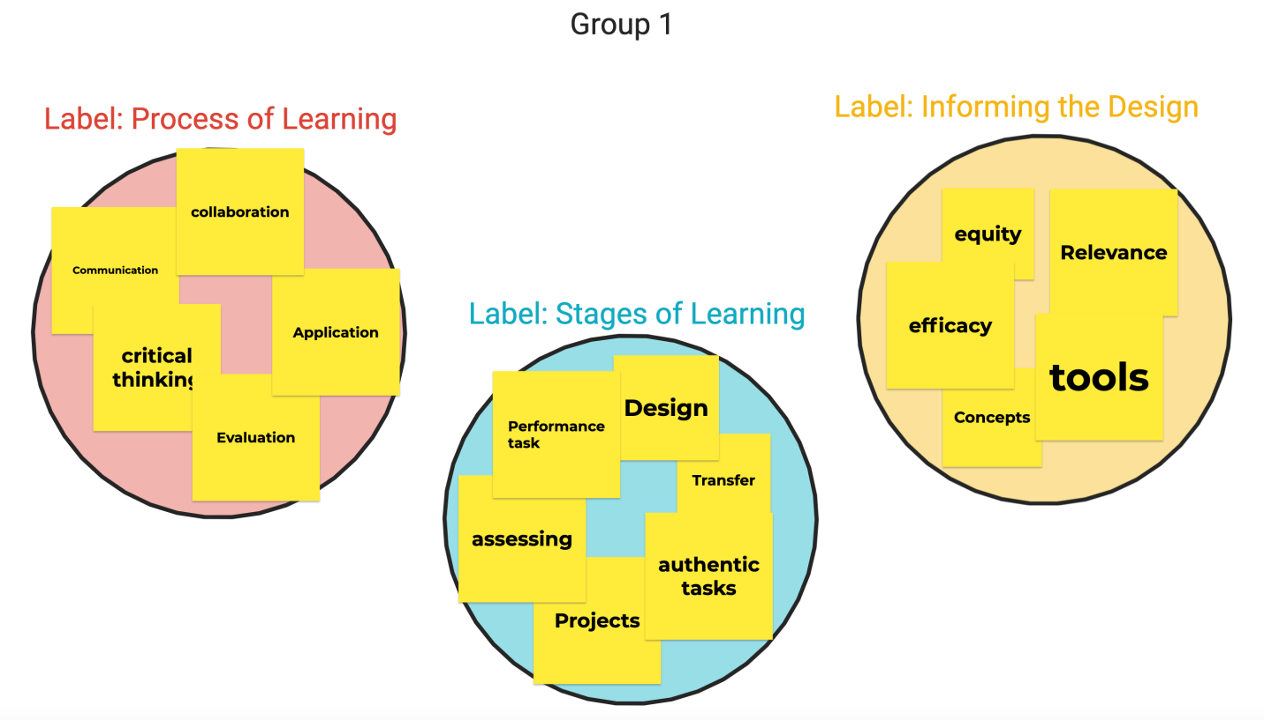
The categories students create and the labels they assign to each category provide insight into their thinking. This step provides informal data about what they know and what gaps or misconceptions exist.
Step 4: Ask students to make predictions about what they expect to learn based on the pile of words.
After sorting the words into categories and generating a label for each, ask them to take a few minutes to review the words, categories, and labels and make a prediction about what they expect to learn based on this pile of words. What big ideas would they expect to explore studying this unit, reading this text, or working through this project?
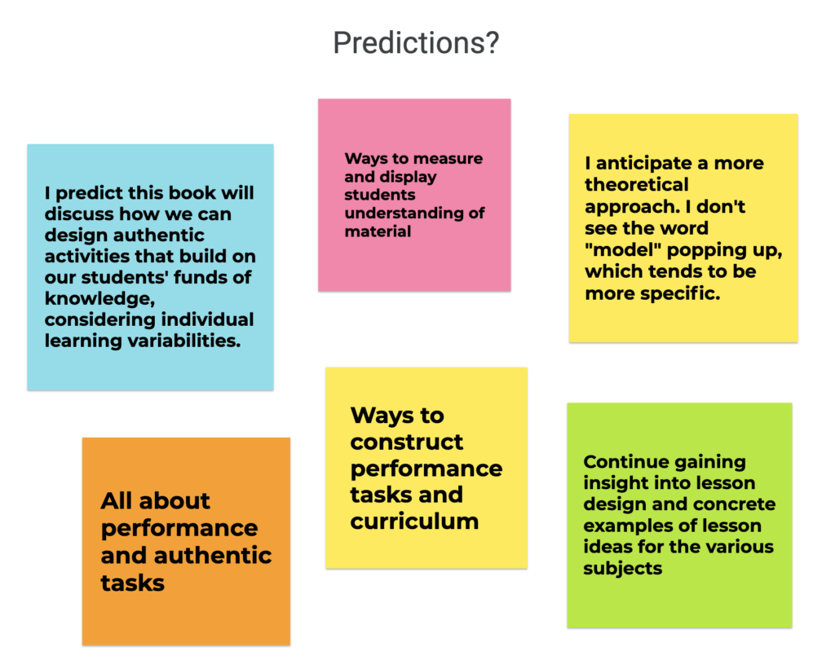
Step 5: As students progress through the unit, text, or project, ask them to revisit their predictions.
Prompt students to revisit these predictions as they make progress through this unit, text, or project. Were their predictions accurate? Do they need to be refined based on what students are learning? Are there additional vocabulary words or terms they want to add to their pile of words?
I modeled this strategy with my teacher candidates hoping that they will use it to drive deeper learning. I created the template below to support them in using this strategy online or in a blended learning environment. Although I included six possible groupings in the “group and label” section, it’s important to tell students that they can create as many groups or categories as they need and to feel free to customize the template.
Pile of Words Template
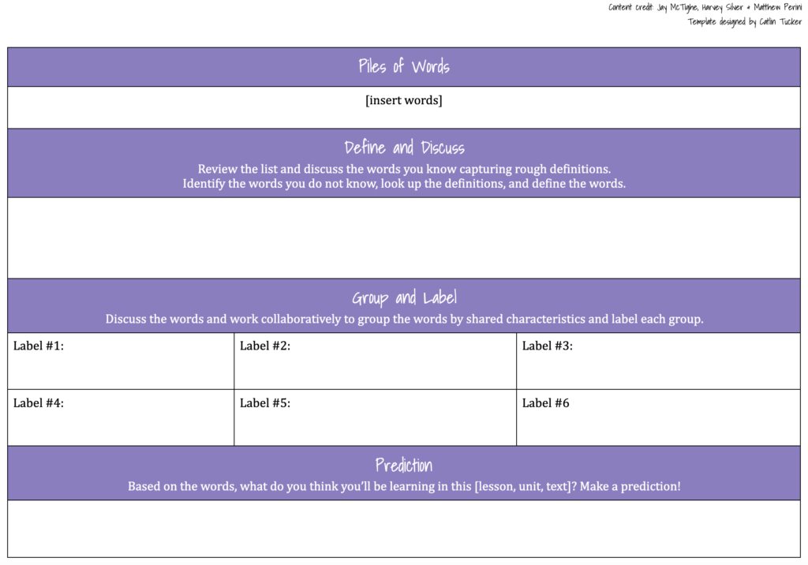
The beauty of this simple strategy is that it can be used at any grade level or in any subject area to drive deeper thinking about vocabulary.

