Пояснительная записка.
Нами проводится исследование по теме «Реализация функционального подхода при формировании грамматического навыка (английские модальные глаголы в функции prohibition, основная школа)». В результате исследования была разработана система упражнений, направленная на формирование и совершенствование грамматического навыка использования модальных глаголов английского языка, выражающих запрет с позиции функционального подхода. Представленная система упражнений включает в себя следующие этапы работы над грамматическим материалом:
- введение/ презентация нового грамматического материала (Grammar Presentation);
- языковые упражнения (Language Booster);
- условно-речевые упражнения: имитативное, подстановочное, трансформационное и репродуктивное (Speech Drills);
- речевые упражнения в монологической и диалогической речи (Modals in situations).
Изучив данную систему упражнений, выразите свое мнение по поводу данного материала. Подходит ли представленная система к тому учебно-методическому комплекту, который вы применяете у себя в школе? Как вы считаете, могли бы вы применять данную систему на уроках английского языка в вашей школе на среднем этапе обучения (7-9 классы)?

GRAMMAR PRESENTATION
Look at the pictures and figure out what do these modal verbs express. In what situation we can use can’t, may not and mustn’t?
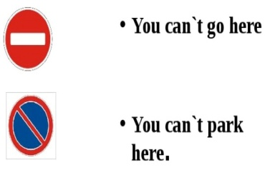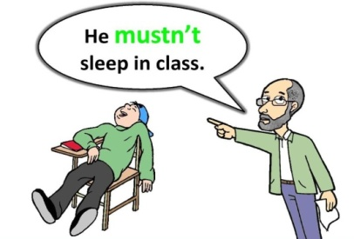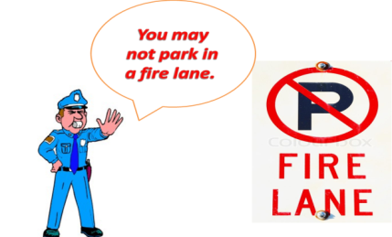
We use can’t to express prohibition when the circumstances do not allow to do something, i.e., there are some obstacles for performing the action.
We use may not to express very official, categorical and strict prohibition. May not mainly occurs in formal instructions.
We use must not to express the action is prohibited either according to a law or a rule or because the speaker forbids it. This meaning is very categorical and strict.

LANGUAGE BOOSTER
Ex.1: Imagine that you are a teacher. Explain to your students the meaning of the highlighted modal verbs. Use the rules which point at the difference between the meanings of the modal verbs.
- You can’t buy cigarettes in British Columbia unless you are 18 years of age. That is the law.
- You can’t talk loudly in the library.
- Non-committee members may not vote on committee issues.
- You can't go into that restaurant without a tie.
- You mustn’t use pencil in this examination. Only pen.
- Guests may not cook food in the rooms.
- You mustn't use your phone in class.
Ex.2: There are a lot of things people are forbidden to do. Tell your friend about it. Fill in the gaps with the modal verbs can’t, may not or mustn’t and use the infinitives. If more than one answer is possible, explain why.
- It is forbidden. You __________ (to do) that.
- You _______ (to drive) in this country unless you are over eighteen.
- People__________ (to enter) the USA without a visa.
- We _________ (to take) books out of this library.
- Alcoholic beverages _________ (to be served) after midnight.
- You __________ (to take) someone else's bike!
Ex.3: There are a lot of rules around us. Imagine that you need to explain them to another person. Decide which of these modal verb (a) or (b), is more appropriate?
- Drivers are not allowed to park here.
(a) can’t
(b) mustn’t
- Students are not allowed to leave the campus after 10 p.m.
- may not
- can’t
- Nobody is permitted to miss classes.
- mustn’t
- may not
- Parents are not allowed to leave the child alone.
(a) may not
(b) can’t
- It, s forbidden to walk dogs here.
- mustn’t
- can’t
- It, s forbidden to turn left here.
- may not
- mustn’t

SPEECH DRILLS
Ex.4: Lisa talks about something that other people are not allowed to do. Tell that you agree with her. Use the model to answer.
Model:
T: Kevin can’t smoke here. He is in a public place.
S: Yes, Kevin can’t smoke here.
- - Fred may not eat the cake. He is in the museum.
- … …
- - Dogs mustn’t run on the grass here. They could ruin the lawn.
- … …
- – Mr. Black can’t tell him about it. It's confidential.
- … …
4. - Tom can’t leave right now. Mr. Smith wants to see him.
- … …
5. Ted may not sing so loudly. Mary’s baby is sleeping now.
- … …
6. - David can’t sleep here. He might miss the stop.
- … …
7. Liz mustn’t watch so much television. Her eyes will hurt.
- … …
Ex. 5: Imagine yourself in the following situations. What are these people forbidden to do else? Use the verbs in brackets to say that you don't approve of their actions.
Model: T: You can’t play the piano, Mary.
S: (play the guitar). And you can’t play the guitar, too.
- - You can’t play hockey, Mike.
- (ski) … …
- - You mustn’t watch TV all day long
-(talk on the phone so much) ... ...
- - Julia, you may not take my dress.
- (take anything without permission)… …
- - Steve may not smoke here.
- (let your friend smoke)… …
- – Students mustn’t make notes in library books.
- (speak loudly in the library) … …
- - You can’t rent this flat .
- (buy it) … …
Ex. 6: Your friend speaks English too bad and he makes mistakes all the time. Express your disagreement with the speaker like in the model.
Model: T: -You can let the dog out.
S: - Oh no. You can’t let the dog out. (The dog may get lost).
- Students can leave the campus after 10 p.m.
- … … (It’s a rule).
- Children can play football in the house.
- … … (They can break anything).
- Visitors may use the employee restrooms.
- … … (Facilities are available in the foyer).
- You may take other people's things without permission.
- … … (People might think you want to steal something).
- We must allow him to eat so much chocolate.
- … … (He will have a terrible toothache).
- You must disturb him.
- … … (He's very busy right now).

Ex.7: Sometimes people do things we don't want they do. Respond to the situation expressing prohibition. Don’t forget to use can’t, may not and mustn’t.
Model: T: Two boys are playing football on the road.
S: You mustn’t play on the road.
- Tom is taking your telephone without permission.
- … …
- It’s really cold today but Anny is opening the window.
- … …
- Jack is wearing a sport costume to the charity concert.
- … …
- Little girl is going to play with the tiger.
- … …
- Mrs. Smith has a headache but Susie is playing the piano.
- … …
- Helen is parking her car in front of the entrance.
- … …
MODALS IN SITUATIONS
Ex. 8: Do you like going to school? Each school has some rules that students aren’t allowed to break. Tell what is forbidden to do in your school?
to smoke to sleep during the class to bring dangerous things
to use mobile phone during the school day to bully other pupils
to leave lesson to bring chewing gum to run in school corridors

We have a lot of rules at our school.
First of all… …
Secondly… …
Besides, … …
More than that… …
But … … anyway.

Ex. 9: Look at the pictures and gossip with your partner about someone you may know like in the example. Don’t forget to use the rules of speech etiquette.
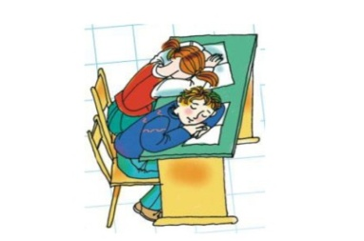 | - You won’t believe what Mark and Helen did yesterday!  - What happened?  - They slept during the class!  - Are you serious?* They mustn’t sleep during the class.

* Are you for real? / No way! / Who would’ve thought? / Unbelievable! /
You won’t believe it! / Guess what? / You’re kidding! / You must be joking!

- 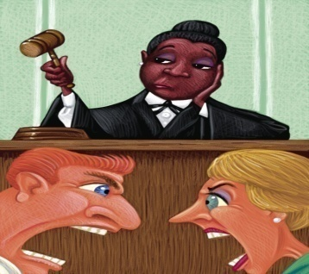 | Ron and Emma  to cream loudly in the courtroom
- 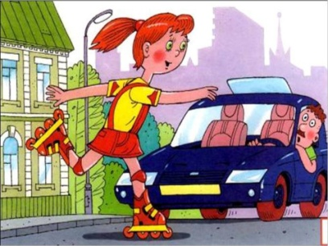 | Alice  to roller skate on the roadway
- 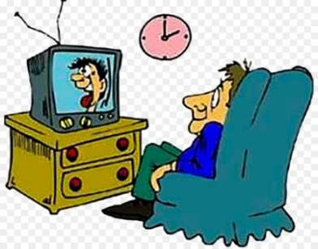 | Mike  to watch TV all night
- 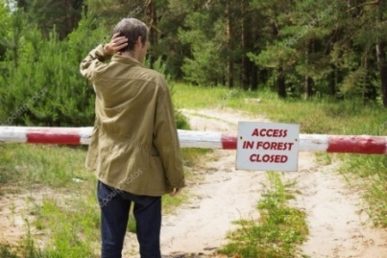 | Dan  to go into the forest
- 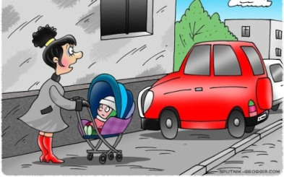 | Steve  to park illegally
- 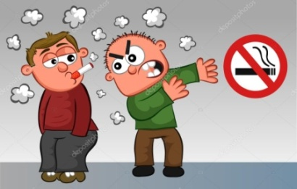 | Peter  to smoke in the wrong place
Mary
to draw graffiti everywhere

Jim
to eat too much fast-food

